**Summary of the idea. This is the section reviewers read to understand the technical solution. Please state the solution clearly. Reviewers may ask: What is the actual technical advancement or improvement provided by this solution?**

This system structure improves the efficiency and effect of fire detection. Furthermore, using this framework in the system makes data exchange faster and more reliable. However, the method proposed in this study achieves an average response time of 5 seconds to detect fire and alert the owners. At the same time, fire pumps are activated, drawing water from the tank and releasing it into fire sprinklers to minimize the fire until the owner and emergency services arrive. Therefore, the proposed system overcomes the challenges of affordability, availability, and responsiveness issues.

**Main Problem Being Addressed in the Project (Every solution targets a certain problem. Please use thissection to highlight the specific problem the solution addresses. This section can be as short or as long asneeded to describe the precise problem the solution addresses**

We use multiple features and situations to identify fires in the proposed fire detection system. Once a fire is detected, our technology takes a live photo of the surrounding area. Flame sensors determine the presence of fire or flame. It works using infrared flame flash technology. A phototransistor is used in this explicit flame detector. Flame detection systems use the infrared spectrum band. Carbon dioxide produced by combustion of organic compound materials has a resonance frequency within this range. Put anything that could catch fire in front of the flame sensor. The flame sensor is triggered when a fire or flame is detected. This sensing relies on variables such as humidity and temperature. Once a fire is detected, the camera captures an image of the fire and sends it to an Android application over a wireless network with the help of a microcontroller. When the temperature rises, the temperature sensor will detect and trigger the buzzer, and the buzzer will sound. The fire extinguisher pump is connected to the IC. If a flame is detected, the IC activates the DC motor and fire extinguisher pump. Sprinklers attached to the pumps spray the extinguishing agent over the entire area affected by the fire.

**Any unique features? Explain?**

Many studies have been done to solve these problems, for example: However, since these systems rely on machine vision, the algorithms require more images for training, and the detection rate is not ideal, the problem of fire detection has not been properly solved. Other methods also have some limitations, mainly slow time response and low precision.

Therefore, this paper aims to minimize false positives, provide a faster response, and provide a new approach to the Internet of Things than previous research mainly using Node-Red. Contributions are as follows

i) Identify which combinations of sensors and algorithms can detect fires accurately and quickly.

ii) We designed and developed a system to detect a fire and activate a fire alarm.

iii) The proposed system assesses the situation and activates sprinkler installations where the fire extinguisher installations are individually designed.

iv) The system analyzes the collected data using the Ubidots platform, which allows for a faster response. Therefore, four points make the proposed system superior in terms of affordability, effectiveness, and responsiveness.

**How simple or complex will the idea’s execution or implementation be? What are the risk factors involved in executing the idea?**

Automatic Fire Extinguishing System has better reliability, portability, cost-effectiveness, a very simple design, good serviceability and operable at almost all places. Soon most of the manual fire control will be replaced by automation for their swift action in case of fire and their location at unconventional positions difficult for human interference. The Government should persuade Construction and Manufacturing Industries to install such automatic systems, which will save both life and property.

**Related Background. This section is used to highlight information that can be used by the reviewers orpatent attorney to help put the solution in proper context. You can think of this section as something similarto the introduction section of an academic publication. This section is specifically reserved for other people’swork (please include competitive work) as well as your past work that you believe will aid the reviewers inunderstanding the technical landscape. Data related to or supporting your solution should not be in thissection, it should be in Section III: “How is this Solution Made and Used.”**

|  |  |
| --- | --- |
| A Mobile-Sensor Fire Prevention System Based on the Internet of Things | This system provides warnings and locates where fires occur in buildings. It is equipped with a temperature sensor, a fire detector sensor, and a smoke detector sensor. When a fire occurs, it will send signals and warnings to the building occupants via their phones. This system can also detect when there is a change in temperature in the building. It will collect every finding of temperature change data from anticipating the presence of fire that will occur. |
| Smart home automation and security system using Arduino and IoT | The design provides simple and cheaper detection, monitoring, and control methods in the domestic field and industry standards to implement IoT. |
| Towards Reducing the damage of fire through firefighting autonomous robot. | The Robot being placed in a room. Then the robot will detect the presence of fire that is present in the chamber. The Robot can detect fire that has waves from 760mm to 1100mm in a distance of 20cm  from three different directions. |

**Related Background. This section is used to highlight information that can be used by the reviewers orpatent attorney to help put the solution in proper context. You can think of this section as something similarto the introduction section of an academic publication. This section is specifically reserved for other people’swork (please include competitive work) as well as your past work that you believe will aid the reviewers inunderstanding the technical landscape. Data related to or supporting your solution should not be in thissection, it should be in Section III: “How is this Solution Made and Used.”**

We identify the fire in our suggested fire detection system using multiple characteristics and situations. Following the detection of a fire, our technology will take real-time photos of the surrounding area. The flame sensor determines whether or not there is a fire or flame present. It works using infrared flame flash technology. A photo transistor is used in this explicit flame detector. The infrared spectral band is used by flame detection systems. Carbon dioxide, which is produced by the combustion of organic compound materials, has a resonance frequency in this range. Put anything that can catch fire in front of the flame sensor. The flame sensor is triggered when it detects a fire or flame. This sensing relies on variables such as humidity and temperature. After detecting fire, the camera will capture the image of the fire, it will be sent to android application with the help of microcontroller through wireless network. As temperature increases the temperature sensor will detect and it will trigger the buzzer and buzzer will blow. The fire extinguisher pump is connected to an IC. If a flame is detected, IC activates the dc motor and fire extinguisher pump. The sprinklers connected to the pump will sprinkle the fire extinguisher throughout the fire affected area.

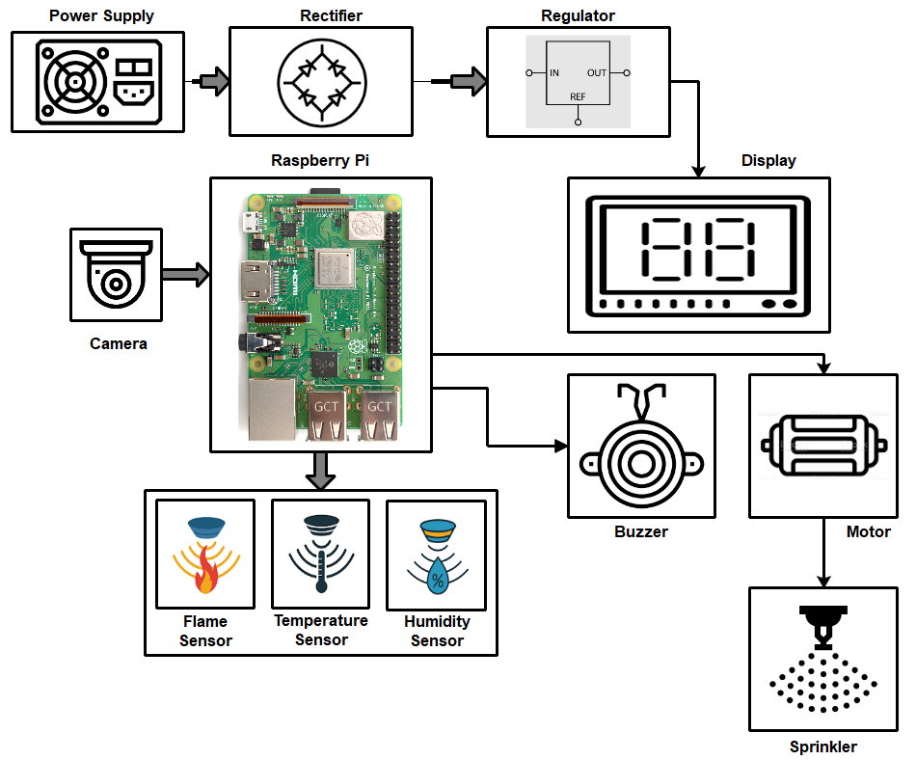

Figure.1.System Architecture for Monitoring Fire System

**13.How is this project made and used: Please describe in as much detail as possible how the innovation isimplemented. This includes details on how you actually make, assemble, synthesize, or build the solutionand details on how the solution is used once it is made. Reviewers will ask: How does the technicalinnovation actually work – or – what is the detailed process to achieve the technical innovation? Please helpconvince the reviewers with supporting statements using as much of the following that is available: yourthoughts, logic, supporting literature, and/or experiments.**

We use a variety of characteristics and conditions to identify fires in the proposed fire detection system. When a fire is detected, our technology takes a live photo of the surrounding area. Flame sensors determine the presence of fire or flame. It uses infrared flame flash technology. A phototransistor is used in this explicit flame detector. Flame detection systems use the infrared spectrum band. Carbon dioxide produced by combustion of organic compound materials has a resonance frequency within this range. Put anything that could catch fire in front of the flame sensor. The flame sensor is triggered when a fire or flame is detected. This sensing relies on variables such as humidity and temperature. Once a fire is detected, the camera captures an image of the fire and sends it to an Android application over a wireless network with the help of a microcontroller. When the temperature rises, the temperature sensor will detect and trigger the buzzer, and the buzzer will sound. The fire extinguisher pump is connected to the IC. If a flame is detected, the IC activates the DC motor and fire extinguisher pump. Sprinklers connected to the pump will spray the fire suppressant throughout the area affected by the fire.



Figure.1.System Architecture for Monitoring Fire System

**put flow chart**